Flask Backend Git Hub Link
Express Frontend Git Hub Link
CI/CD Deployment Assignment
You are required to deploy a Flask backend and an Express frontend on an Amazon EC2 instance. Additionally, implement a CI/CD pipeline using Jenkins to automate the deployment process.

Part 1: Deploy Flask and Express on a Single EC2 Instance
- Objective:
  - Deploy both the Flask backend and the Express frontend on a single Amazon EC2 instance.
- Steps:
  - Provisioning the EC2 Instance:
    - Launch an EC2 instance on AWS (you can use a free-tier eligible instance).
    - SSH into the instance and install the following dependencies:
      - Python for Flask.
      - Node.js for Express.
      - Git for pulling the application code.
  - Application Setup:
    - Clone the Flask and Express repositories onto the EC2 instance.
    - Install the required dependencies for both applications using pip and npm.
    - Configure both applications to run on different ports (e.g., Flask on port 5000 and Express on port 3000).
    - Start the applications using process managers like pm2 or systemd to ensure they remain active.
- Deliverables:
  - A running EC2 instance with Flask and Express accessible via the instance's public IP.
  - A description or diagram of the deployed architecture.
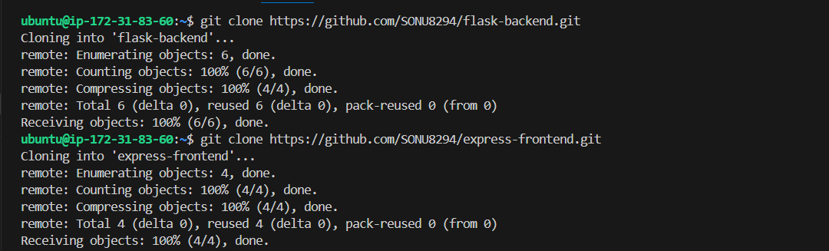
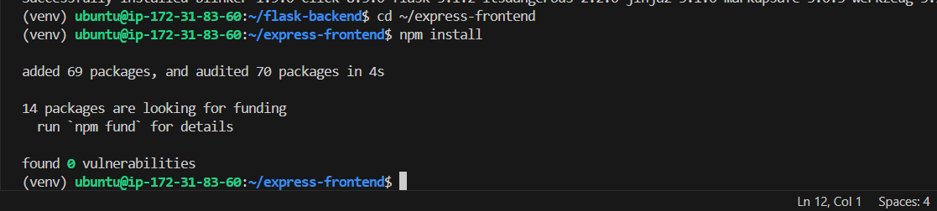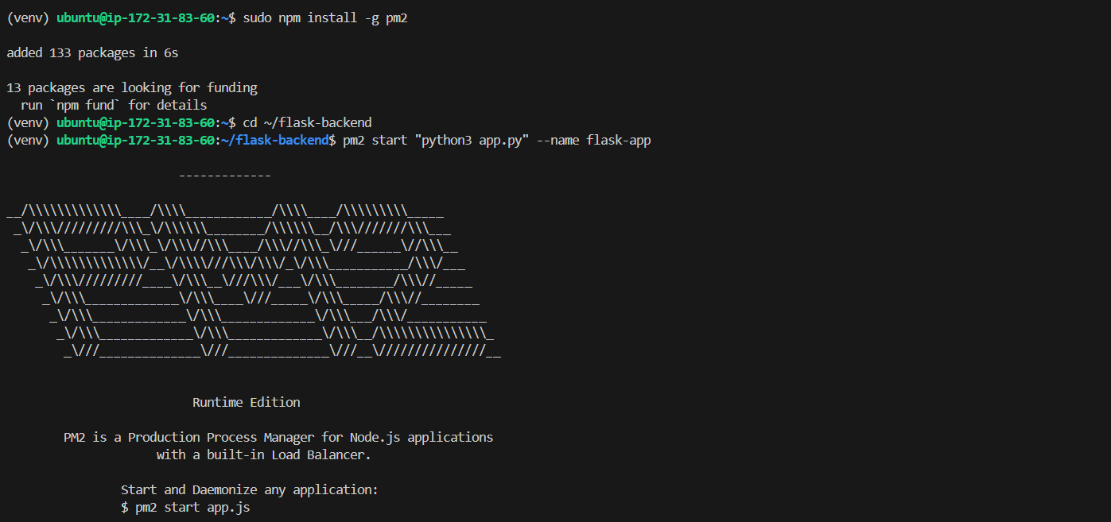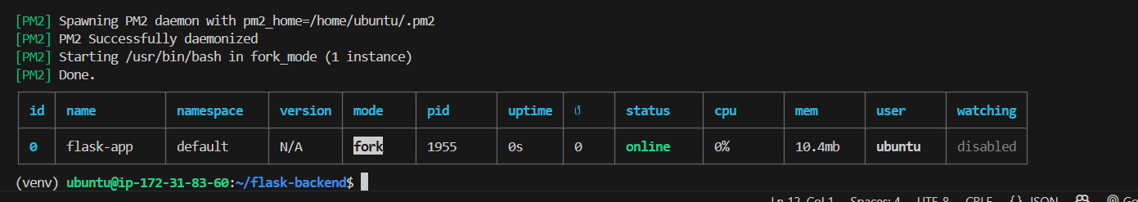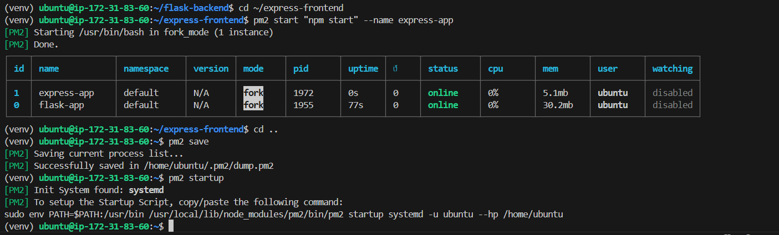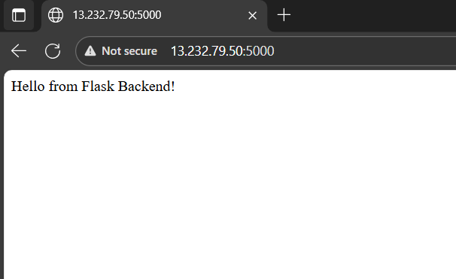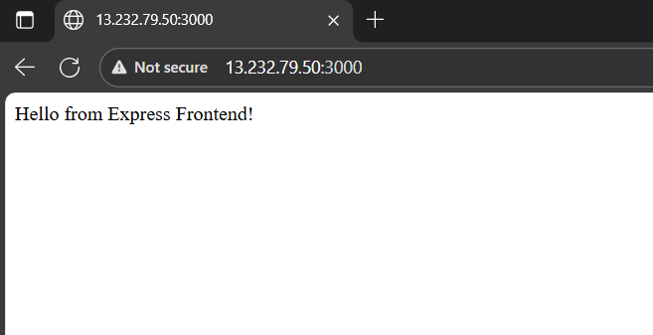

Part 2: Implement CI/CD Pipeline Using Jenkins
- Objective:
  - Automate the deployment of Flask and Express applications using Jenkins.
- Steps:
  - Install Jenkins:
    - Install Jenkins on the same EC2 instance or on a separate machine.
    - Configure Jenkins by installing essential plugins like Git, NodeJS, and Python.
  - Set Up Jenkins Pipeline:
    - Create two separate Jenkins pipelines for the Flask and Express applications.
    - Pipeline Steps:
      - Pull the latest code from the respective Git repositories.
      - Install dependencies for Flask (pip install -r requirements.txt) and Express (npm install).
      - Restart the applications using the process manager (e.g., pm2 restart <app>).
  - Triggering the Pipeline:
    - Set up a GitHub webhook to trigger the Jenkins pipeline on every push to the repositories.

  - Optional Enhancements:
    - Add testing stages to the pipeline for both applications.
    - Configure environment variables in Jenkins for managing sensitive data like API keys.
- Deliverables:
  - A fully functional CI/CD pipeline that automates the deployment process for Flask and Express.
  - A Jenkins pipeline script (Jenkinsfile) for each application.
  - Evidence of the pipeline working (e.g., screenshots of successful builds and deployments).

